2023-2024 CALENDAR
CENTRAL PRESBYTERIAN CHURCH
PRESCHOOL-KINDERGARTEN
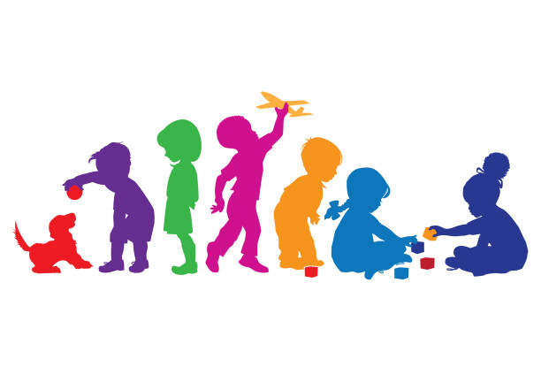

August 3 First Day of School

September 4 Labor Day Holiday

October 6 Student Holiday

October 18, 19, 20 Picture Days

October 30 & 31 Student Holidays

November 22 - 24 Thanksgiving Holidays

December 8 Christmas Program @ 9:30 am

December 18 – January 2 Winter Holidays

January 3 Students Return from Break

January 15 Student Holiday

February 16 & 19 Student Holiday

March 11 Student Holiday

March 29 - April 5 Spring Break

April 16 Open House

April 22 -26 Student Evaluations for Fours and Kindergarten

April 29 – May 2 Parent/Teacher Conferences

May 10 (tentative date) Spring Program

May 21 Last Day of School

